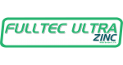
1. PRODUCT IDENTIFICATION
Product identifier on label: FULLTEC ULTRAZINC
EPA Registration: Exempt
Common name: Foliar fertilizer
Chemical description: Mixed mineral fertilizer
Recommended use: See product label for full directions for use.
Restrictions for use: See product label for any potential use restrictions.

Guaranteed by:
Spraytec Fertilizers LLC
3219 99th St
Urbandale, IA 50322
(515) 252-7777. For product information or assistance 1-800-889-5127

Manufactured by:
Latina Agro Ind. e Com. de fertilizantes LTDA
Rodovia PR-317, 8065, Parque Industrial Sul
Maringá, Paraná, Brazil; CEP 87065-005
+55 (44) 4009-2050
CNPJ: 06.287.157/0005-50 | I.E: 90.376.806.10

2. HAZARD IDENTIFICATION
Emergency Overview: Hazy beige liquid with a mild odor. This product does not meet the regulatory definition of a hazardous chemical. However, may cause skin, eye and respiratory irritation.
Potential Health Effects
Eyes: May cause mild but reversible eye irritation.
Skin: May cause mild but reversible skin irritation.
Inhalation: May cause minor irritation of the upper respiratory tract.
Ingestion: May cause minor irritation of digestive tract.
Preexisting conditions: None known
Chronic health effects: None known
Carcinogenicity
NTP: Not listed
IARC: Not listed
OSHA: Not listed

Potential environmental effects: Under high concentration, may contaminate waterways by pH reduction.
Physical and chemical hazards: Not flammable product. May react with incompatible materials (see section 10).
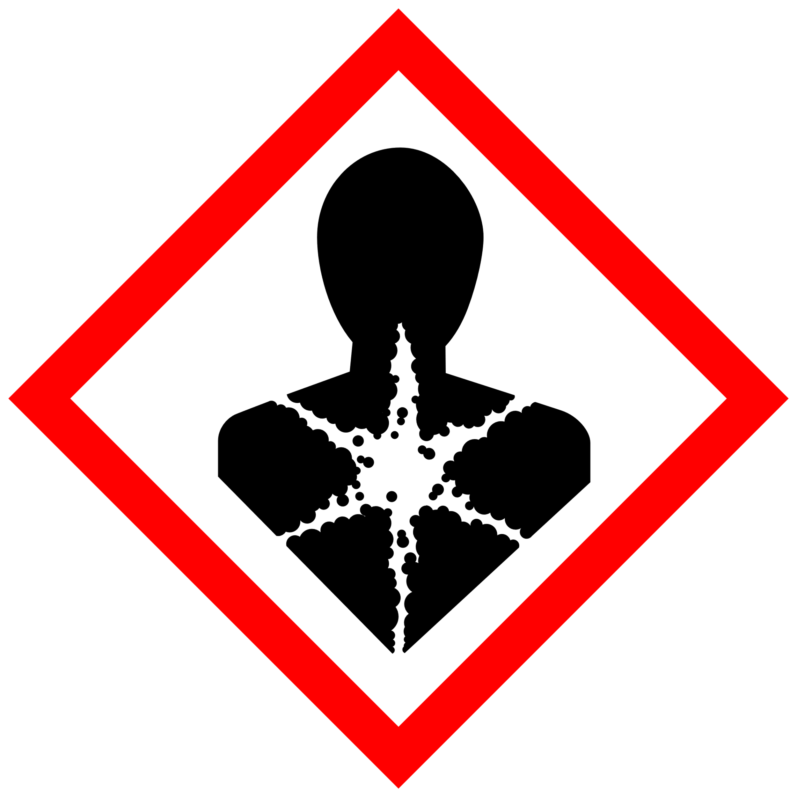
Signal word (OSHA): CAUTION
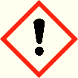
Hazard symbols:

Hazard statements: None required
Precautionary statements: Prevention: See section 8 for personal protective equipment.
Response: See section 4 for first aid information.
Storage: See section 7 for storage information.
Disposal: See section 13 for disposal information.

3. COMPOSITION/INFORMATION ON INGREDIENTS
Formulation Type: Aqueous Solution
Composition: Phosphoric acid, urea, potassium chloride, copper sulfate, boric acid, zinc sulfate, manganese sulfate, sodium molybdate, nonionic surfactant, tensoactives, carboxylic acid, EDTA, amino acid, citric acid, and water.
Guaranteed Analysis: Nitrogen (N) - 1%
Available Phosphate (P2O5) - 5%
Soluble Potash (K2O) - 3%
Sulfur (S) - 3.7%
Boron (B) - 0.1%
Copper (Cu) - 0.1%
Manganese (Mn) - 6%
Molybdenum (Mo) - 0.5%
Zinc (Zn) - 0.7%
Derived from: Urea, phosphoric acid, potassium chloride, copper sulfate, boric acid, copper sulfate, manganese sulfate, sodium molybdate, and zinc sulfate.

4. FIRST AID MEASURES
Have the product container, label or Safety Data Sheet with you when calling Spraytec (1-800-889-5127), a poison control center or doctor, or going for treatment.
Ingestion: If swallowed: Call a poison control center or doctor immediately for treatment advice. Give water to the victim to dilute the material. Do not induce vomiting unless told to do so after calling to a poison control center or doctor. Do not give anything by mouth to an unconscious person.
Eye contact: If in eyes: Hold eye open and rinse slowly and gently with clean water for 15-20 minutes. Remove contact lenses after 5 minutes, if present, then continue rising eye. Seek medical attention if eye irritation persists.
Skin contact: If on skin or clothing: Take off contaminated clothing under a shower and wash it before re-using. Rinse skin with plenty of water and soap for 15-20 minutes. Seek medical attention if irritation occurs.
Inhalation: If inhaled: move person to fresh air. If person is not breathing, call 911 or ambulance, and assist breathing as needed. Seek medical attention for further treatment advice.
Warning: Do not give anything by mouth to an unconscious person.

5. FIRE FIGHTING MEASURES
Suitable extinguishing media: Not flammable. Use media suitable for combustibles involved in fire.
Unsuitable extinguishing media: Not flammable.
Specific hazards: During a fire, irritating and possibly toxic gases may be generated by thermal decomposition or combustion.
Special protective equipment and precautions for firefighters:
Wear full protective clothing and self-contained breathing apparatus. Evacuate nonessential personnel from the area to prevent human exposure to fire, smoke, fumes, or products in combustion.

6. ACCIDENTAL RELEASE MEASURES
Personal precautions: Refer to section 8 for personal protective equipment to be worn during containment and clean-up of a spill involving this product.
Environmental precautions: Keep spilled product from entering sewers or waterways.
Methods for containment: Contain spilled product at its source. Contain the spill to prevent from spreading or contaminating soil or from entering sewage and drainage systems or any body of water.
Methods for clean-up: Cover contained spill with an inert absorbent material such as sand, vermiculite or other appropriate material. Vacuum, scoop or sweep up material and place in a container for disposal. Do not place spilled material back in original container.

7. HANDLING AND STORAGE
Precautions for safe handling: Ensure adequate ventilation during handling and use. Always use personal protective equipment (see section 8) while handling this material. Immediately clean up spills that occur during handling. Keep containers closed when not in use. Practice good hygiene after using this material, especially before eating, smoking, using the toilet, or applying cosmetics.
Precautions for safe storage: Store the material in a well ventilated, secured area out of reach of children and domestic animals. Do not store food, beverage, or tobacco products in the storage area. Keep product away from any source of heat or flame and out of direct sunlight at moderate temperatures. Protect packaging from physical damage. Store product in the original container
8. EXPOSURE CONTROLS/PERSONAL PROTECTION
Respiratory protection: For most conditions, no respiratory protection should be needed. If airborne concentration exceeds exposure limits, use a NIOSH approved air-purifying respirator with cartridges/canisters approved for organic vapors.
Eye protection: Chemical safety goggles are recommended to prevent eye contact. Contact lenses are not protective eye devices.
Skin protection: Chemically protective gloves, Long-sleeve shirt, long pants and shoes plus socks are recommended to prevent skin contact.
Work/Hygienic practices: Never eat, drink, nor use tobacco in work areas. Practice good hygiene after using this material, especially before eating, drinking, smoking, using the toilet, or applying cosmetics.

9. PHYSICAL AND CHEMICAL PROPERTIES
Physical state: Liquid
Appearance: Hazy beige liquid
Odor: Low phosphoric odor
Odor threshold: Not available
Solubility in water (wt%): Emulsifiable
Vapor pressure (mm Hg): Not available
Vapor density (Air=1): Not available
pH: 3.0 (0.5% solution in deionized H2O @77° F [25°C])
Melting point/freezing point: Not available
Initial boiling point/boiling range: Not available
Flammable limits (% in Air): Not available
Flammability: Not available
Viscosity: Not available
Specific Gravity (H20=1): 1.62
Density (lbs/gallon): 13.52 lbs/gallon
Flash point: Not available
10. STABILITY AND REACTIVITY
Reactivity: Not reactive
Chemical stability: Stable under normal use and storage conditions.
Possibility of hazardous reactions: None known
Conditions to avoid: Store above 32°F (0°C).
Avoid high temperatures and sun exposition.
Incompatible materials: Strong bases, Strong acids, and Strong oxidizing agents.
Hazardous decomposition products: None known.

11. TOXICOLOGICAL INFORMATION
Acute: Not determined
Chronic toxicity: No records
Potential health effects: Eyes: May cause mild but reversible eye irritation.
Skin: May cause mild but reversible skin irritation.
Inhalation: May cause minor irritation of the upper respiratory tract.
Ingestion: May cause minor irritation of digestive tract.

12. ECOLOGICAL INFORMATION
Ecotoxicity
Fish acute and prolonged toxicity: Not determined
Aquatic invertebrate acute toxicity: Not determined
Aquatic plant toxicity: Not determined
Bird acute and prolonged toxicity: Not determined
Honeybee toxicity: Not determined
Environmental Effects
Mobility: Water soluble
Persistence and degradability: Not persistent in soil. Biodegradable.
Bioaccumulative potential: Low bioaccumulation potential.
Other adverse effects: Avoid spilling product to waterways.

13.DISPOSAL CONSIDERATIONS
Disposal: Do not reuse product container. Dispose of products containers, waste containers, and residues according to local, state, and federal health and environmental regulations.
Container: Triple rinse and recycle the container or dispose of in accordance with local, state and federal health and environmental regulations.

14. TRANSPORT INFORMATION
International Regulations
DOT (ground): This product is not regulated by the U.S. department of transportation as a hazardous material for ground shipment.
Water transport (Sea): IMGD – International maritime dangerous goods code.
Air transport (airplane): IATA
Comments
Proper shipping name: Mixed mineral fertilizer
Hazard class: Not determined
Identification number: Not determined
Packing group: Not determined
Hazardous substance: No

15. REGULATORY INFORMATION
This product is not regulated by the U.S. department of transportation as a hazardous material.
Risks and safety information can be found on Label.

16. OTHER INFORMATION
The information presented herein is based on available data from reliable sources and is correct to the best of SPRAYTEC FERTILIZERS Knowledge. SPRAYTEC FERTILIZERS LLC makes no warranty, express nor implied, regarding the accuracy of the data or the results obtained from the use of this product. Nothing herein may be construed as recommending any practice or any product in violation of any law or regulations. The user is solely responsible for determining of the suitability of any material or product for specific propose and for adopting any appropriate safety precautions. We disclaim all liability for injury or damage stemming from any improper use of the material or product described herein.
Revision date: 01/07/2021

